
GARDEN GROVE UNIFIED SCHOOL DISTRICT
Food Services
Field Trip Lunch Request Form 24-25

In order to ensure availability and delivery, please request Field Trip Lunches fifteen (15) business days prior to the trip.

School _ _ Today’s Date__ _ Requested By

Phone # Grade _ _ Room Number

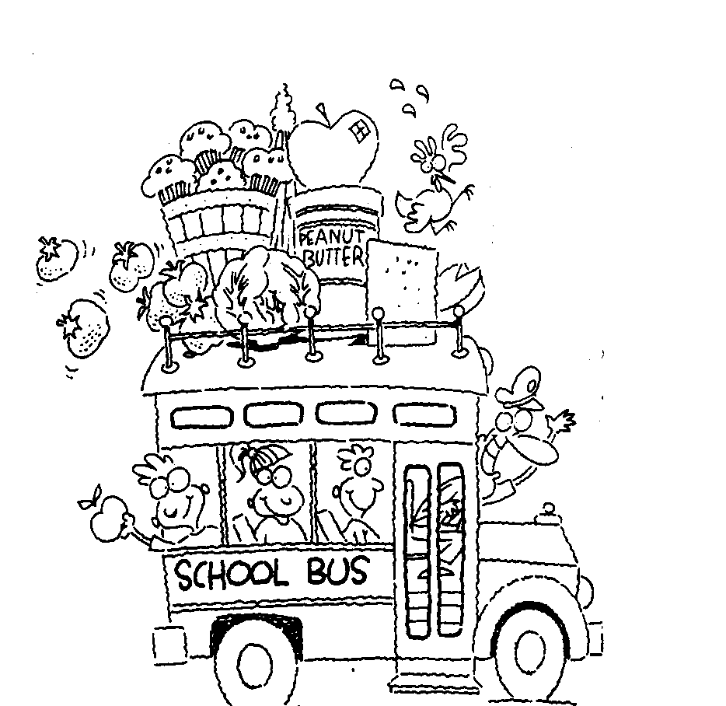
Date of Trip Time Lunches will be picked up from the kitchen (Optional)

SACK LUNCH: Every lunch includes: Entree, Juice Slush, Fruit,
and cookie or crackers. Milk is optional. (Menu subject to change)

Total Number of Student Lunches __ Number of Special Meals _

Number of Adult PAID lunches @ $6.50 =

Special meals (Full Name & Student ID #)
FIELD TRIP PROCEDURE

Sack lunches must be offered to all students.

❑ The Secretary will send a hard copy via district mail or email the Field Trip Lunch Request Form to the site’s Central Kitchen Manager (not the FSO) 15 business days prior to the trip. Keep a copy for your records.

❑ Please include the following on your field trip permission/information letter sent to parents.

_____Yes, please order a sack lunch for my child.
_____No thank you. My child will bring his/her own lunch on the day of the field trip.

- The number of sack lunches ordered is determined by the responses on the field trip permission form completed by a parent. If sack lunches exceed the number of students actually taking a lunch, the extra meals will be charged to the school at $6.50 each.

❑ Students requiring a special meal must be listed on the Field Trip Lunch Request Form, including full name and student ID number. Special meals will be provided ONLY for students who have an approved Special Meal Form on file with the Food Service Department. Your Health Aide can facilitate with a Special Meal Form.

❑ The Secretary must call the site Central Kitchen Manager two (2) days before delivery to confirm your order.

- A teacher’s classroom attendance list must be used as a roster. Students receiving a sack lunch are marked on the roster at the time lunches are handed out. This roster must be given to the Secretary upon returning to school. The Secretary will provide the roster to the lead food service worker. Meals will not be counted for students that are not present at the field trip.

❑ To cancel an order, you must call your Central Kitchen Manager/Lead with four (4) days advanced notice. If the order is not cancelled and the sack lunches are prepared for your classroom, these meals will be charged to your school site at $6.50 each. An exception will be made for inclement weather.

_________________________________________________________________________________________________________________________________________________________________________________________________________________________________
(Food Service Department Use Only)
Date Lunch Request Confirmed _ _Central Kitchen Manager _ Revised 07/24

